LAB TASK# 4
Name: Hifza Hussain
Roll Number: 330
Section: BSAI-3A
Task 1: Manual Calculation of g, h and f
Supplied Campus Graph
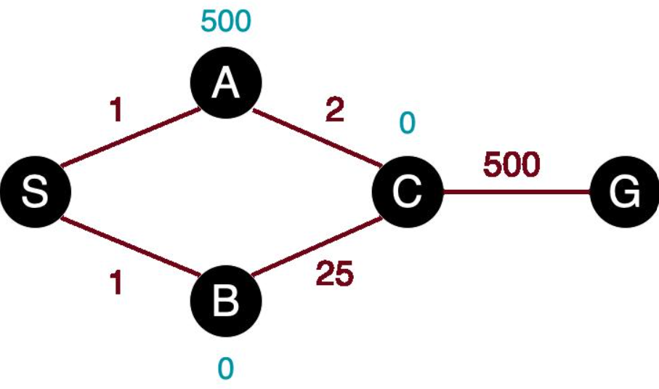The supplied graph is:
Edge | Cost
S → A | 1
S → B | 4
A → C | 2
B → G | 5
C → G | 3

Supplied Heuristic Values
Node | H(n)
S | 5
A | 4
B | 4
C | 2
G | 0

Three Expansions
Selected Node: S
g(S)=0
h(S)=5
f(S)=0+5=5
Expand S and generate A and B.
Frontier Node | g | h | F
A | 1 | 4 | 5
B | 4 | 4 | 8

Next selected node: A
Reason: A has the lowest f-value, 5.
Selected Node: A
g(A)=0+1=1
h(A)=4
f(A)=1+4=5
Expand A and generate C.
Frontier Node | g | h | F
B | 4 | 4 | 8
C | 3 | 2 | 5
Next selected node: C
Reason: C has f=5, which is lower than B's f=8.
Selected Node: C
g(C)=1+2=3
h(C)=2
f(C)=3+2=5
Expand C and generate G.
Frontier Node | g | h | F
B | 4 | 4 | 8
G | 6 | 0 | 6
Next selected node: G
Reason: G has f=6, which is lower than B's f=8.
Manual Calculation:
Expansion | Selected Node | g | h | F
1 | S | 0 | 5 | 5
2 | A | 1 | 4 | 5
3 | C | 3 | 2 | 5

The next selected node after the third expansion is G.

Task 2: A* and UCS Comparison
A* Python Code:
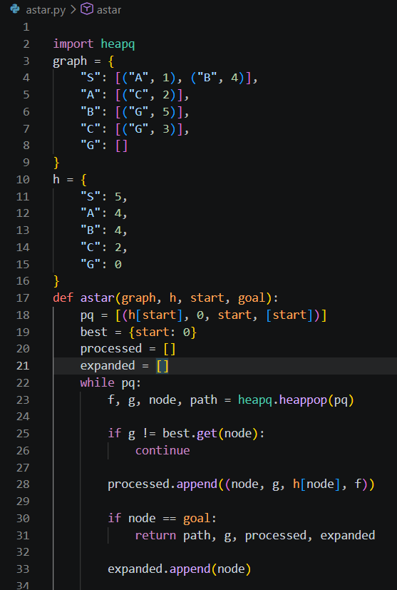
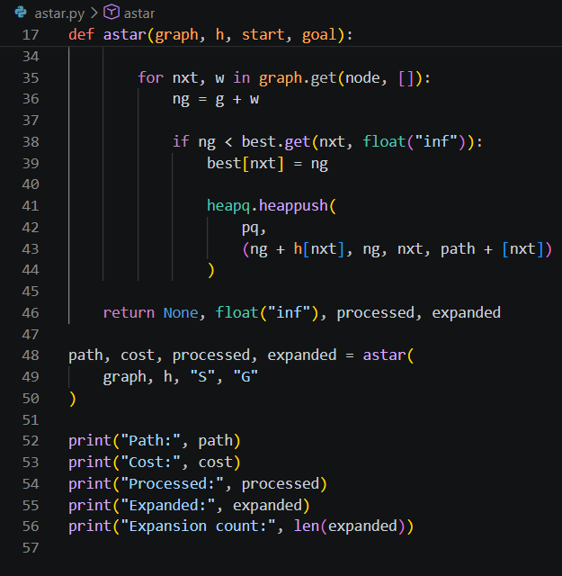
A* Results
Node | g | h | f
S | 0 | 5 | 5
A | 1 | 4 | 5
G | 3 | 2 | 5
C | 6 | 0 | 6

A* Output:
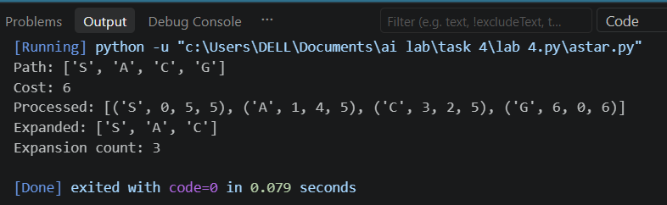
Independent Path Cost Verification:
S-A-C-G
Cost=1+2+3=6
UCS Python Code
UCS is equivalent to A* with:
h(n)=0
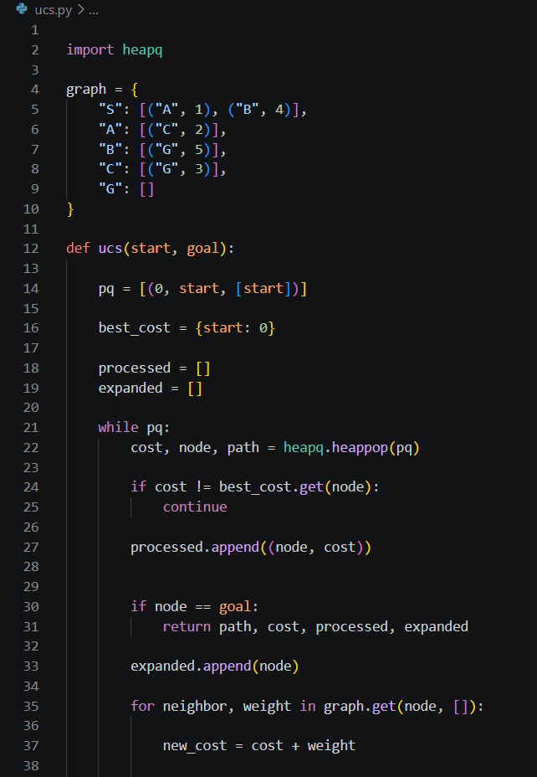
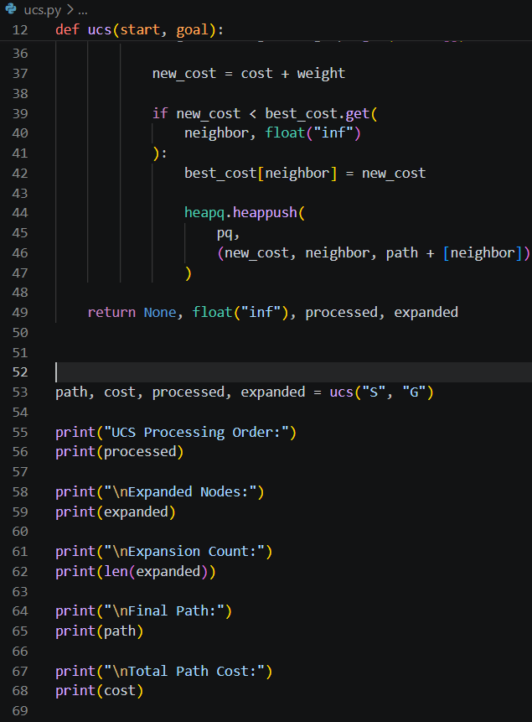
UCS Results
Processing Order
Node | g | h | f
S | 0 | 0 | 0
A | 1 | 0 | 1
C | 3 | 0 | 3
B | 4 | 0 | 4
G | 6 | 0 | 6

UCS Output:
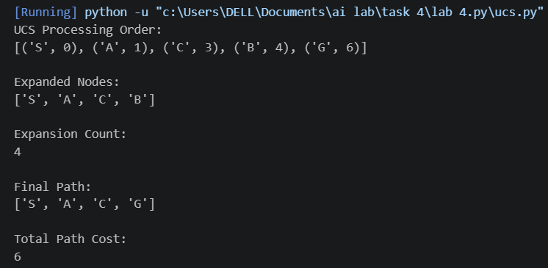
A* vs UCS Comparison:
Feature | A* | UCS
Heuristic | Supplied h(n) | Zero
Path | S-A-C-G | S,A,C,G
Path Cost | 6 | 6
Processed Nodes | S,A,C,G | S,A,C,B,G
Expanded Nodes | S,A,C | S,A,C,B
Expansion Count | 3 | 4
Optimal | YES | YES

Explanation
A* expands fewer nodes because the heuristic estimates the remaining cost and guides the search toward G.
UCS has no heuristic information, so it expands B before selecting G.
The goal node is processed but not counted as expanded because its successors are not examined. Stale queue entries are ignored and are not counted. The same counting convention is used in both runs.

Task 3: Heuristic Overestimation Experiment
Original and Modified Heuristic
The manual instructs us to change only h(C) from 2 to 10.
Node | Original h | Modified h
S | 5 | 5
A | 4 | 4
B | 4 | 4
C | 2 | 10
G | 0 | 0

True Remaining Cost of C
The actual remaining cost from C to G is:
C--G=3
Original heuristic:
h(C)=2
Modified heuristic:
h(C)=10
Since:
10>3
the modified heuristic overestimates the remaining cost and is no longer admissible.
Modified A* Calculation
After expanding S:

Node | g | h | f
A | 1 | 4 | 5
B | 4 | 4 | 8
A is selected.
After expanding A:
Node | g | h | f
B | 4 | 4 | 8
C | 3 | 10 | 13
B is now selected because:
8<13
Expand B:
g(G)=4+5=9
h(G)=0
f(G)=9+0=9
Frontier:
Node | g | h | f
G | 9 | 0 | 9
C | 3 | 10 | 13
G is selected before C.
Modified A* Results
- Processing Order: S, A, B, G
- Expanded Nodes: S, A, B
- Expansion Count: 3
- Returned Path: S → B → G
- Total Cost: 9

Independent cost verification:
4+5=9
Comparison of Original and Modified Heuristic
Experiment | Path | Cost | Expansion Count
Original h | S-A-C-G | 6 | 3
Modified h(C)=10 | S-B-G | 9 | 3
UCS | S-A-C-G | 6 | 4
Discussion
The overestimated heuristic caused A* to choose the more expensive path S-B-G.
The original optimal path has cost 6, whereas the modified path has cost 9.
The expansion count remained 3, but the returned path and total cost changed.
An overestimating heuristic can remove the optimality guarantee because A* may prioritize a suboptimal goal before exploring the optimal path.
Even if an overestimated heuristic produces the optimal result in a particular run, that does not prove the heuristic is safe for all problems.
Failure Case and Edge Case Analysis
Unreachable Goal Experiment
Modify the graph by removing both edges leading to G:
- B → G
- C → G
Modified graph:
graph = {
"S": [("A", 1), ("B", 4)],
"A": [("C", 2)],
"B": [],
"C": [],
"G": []
}
Expected Behavior:
Algorithm | Expected Result
A* | No path found
UCS | No path found
Returned Path | None
Cost | Infinity
Explanation
The goal G is unreachable because no edge connects it to the reachable graph.
Both algorithms eventually empty their priority queues and terminate without finding a solution.
Proposed Improvement
The implementation should:
- Validate start and goal nodes.
- Detect an empty priority queue.
- Return a clear NO_PATH status.
- Handle disconnected graphs.
- Avoid accessing missing graph keys.
5. Reflection
During this lab, I learned how informed search algorithms use heuristic information to guide the search process.
I understood that:
- g(n) represents the actual cost from the starting node.
- h(n) estimates the remaining cost.
- f(n) combines actual and estimated costs.
- A* uses heuristic information to reduce unnecessary expansions.
- UCS is equivalent to A* with a zero heuristic.
- An admissible heuristic does not overestimate the actual remaining cost.
- An overestimating heuristic can cause A* to return a suboptimal path.
I also learned the importance of testing algorithms using different graph configurations and comparing their actual expansion counts.
6. Responsible Practice
- Use the supplied graph and heuristic values accurately.
- Document all assumptions and calculations.
- Keep graph, endpoints and counting conventions identical during comparisons.
- Independently verify path costs.
- Test edge cases and unreachable goals.
- Clearly report when a heuristic violates admissibility.
- Cite borrowed code and factual sources.
- Avoid uploading credentials or private information.
7. Final Conclusion
This lab demonstrated the working of A* and UCS on a campus routing graph.
A* found the optimal route S-A-C-G with total cost 6 and expanded 3 nodes. UCS found the same optimal route with cost 6 but expanded 4 nodes.
The heuristic overestimation experiment showed that changing only h(C) from 2 to 10 caused A* to return S-B-G with cost 9 instead of the optimal cost 6.
Therefore, heuristic quality is important for both search efficiency and optimality.

